

Disability Access and Inclusion Plan

December 2025 – December 2028


Acknowledgement of Country
We acknowledge that we live, work and deliver services, primarily on the lands of the Wurundjeri Woi Wurrung and Bunurong peoples of the Kulin nation.
We honour Aboriginal and Torres Strait Islander Peoples as the First Peoples and acknowledge their ongoing connection to country, land, language, Lore, stories, sea, sky and waterways. We pay our respects to all First Nations Peoples, Ancestors as well as Elders past and present. We acknowledge that sovereignty has never been ceded.
We acknowledge that Aboriginal and Torres Strait Islander women and families continue to be disproportionately affected by family violence due to the ongoing impacts of colonisation.

Commitment to diversity, equity and inclusion
When people feel heard, valued, validated and understood, they can safely interact, engage and collaborate. We strive to provide safe, diverse, inclusive and accessible services and experiences for all. We recognise we have a leadership role to play in championing diversity, equity and inclusion.
We support all victim survivors of diverse abilities, ages, genders, bodies, sexualities, relationships, faiths, and cultures; committing to our vision of a community free from family violence, where everyone is safe.
Contents
Message from our Chief Executive Officer 5
About us 6
Why we’re taking action 6
Our commitments 7
The social and human rights models of disability 8
Using person first language 8
Driving change through this Plan 9
Our focus areas 10
Partnering with people with disability and disability organisations 11
Increasing employment and building workforce capability 11
Making our spaces and communications accessible 12
Improving service access and disability inclusive family violence practice 12

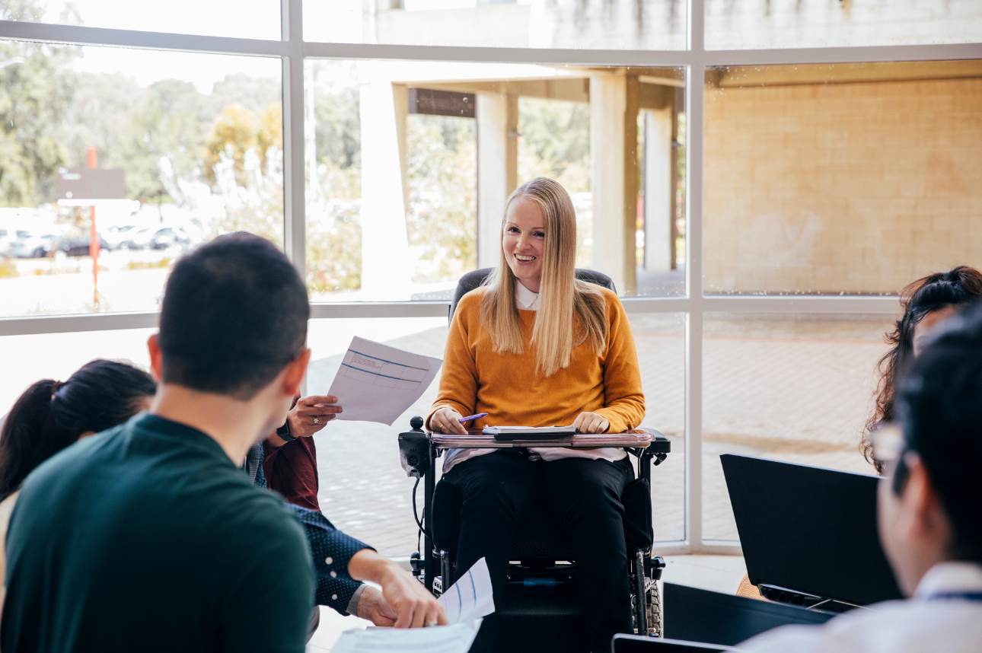

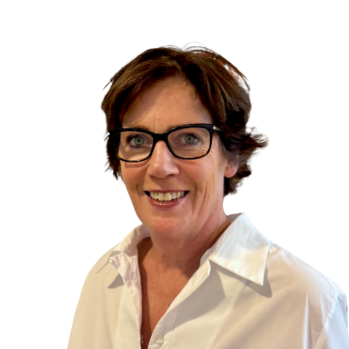
Message from our Chief Executive Officer
I am proud to introduce FVREE’s inaugural Disability Access and Inclusion Plan (the Plan).
Our vision is a community free from family violence, where everyone is safe. We know that people with disability experience family violence at disproportionately higher rates and recognise the urgent need for stronger prevention, early intervention and response measures.
This Plan outlines the actions we will take over the next three years to embed disability access and inclusion within our organisation and across our sphere of influence. Our commitment extends to creating an environment that is accessible and inclusive for both our people and those we support.
Central to this work is ensuring that the voices and perspectives of people with lived experience of disability guide and shape our approach. We acknowledge the lived and living experiences of people with disability, as well as their families, carers, and supporters. We honour their resilience and strength in challenging generations of discrimination, coercion, institutionalisation, violence and neglect, while continuing to advocate for inclusion, empowerment, and human rights.
I extend my sincere thanks to the members of our Disability Working Group for their invaluable contributions to the development of this Plan, particularly those who shared their lived experience of disability, and to Women with Disabilities Victoria for their expert guidance and support throughout this process.
Megan Phelan

About us
FVREE is a specialist family violence organisation that works across the continuum of family violence from prevention, early intervention and response to recovery.
Our programs and services are designed to be culturally safe, inclusive, and accessible. We strive to create an environment where safety and inclusion are fundamental, diversity is valued, and every individual is treated with fairness and respect. We aim to provide the resources and opportunities for all people to participate in our organisation.
We employ around 170 staff, most of whom are family violence practitioners working directly with victim survivors residing on Wurundjeri and Bunurong Country. Our services operate across the local government areas of Boroondara, Knox, Manningham, Maroondah, Monash, Whitehorse, and Shire of Yarra Ranges, with our Prevention and Education programs reaching communities across Victoria.
We uphold our responsibilities under key legislation, including the Disability Discrimination Act 1992 (Cth) and Equal Opportunity Act 2010 (Vic). We are guided by the principles of the Charter of Human Rights and Responsibilities Act 2006 (Vic) and comply with the Victorian Social Services Standards and Child Safe Standards.

Why we’re taking action
Gender inequality and other forms of discrimination increase the risk of family violence and make it harder to recognise abuse, report it, and access support. We know people with disability experience higher rates of family, domestic, and sexual violence compared to those without disability.
Children and young people with disability are also disproportionately affected, experiencing family violence at higher rates than their peers without disability. We recognise exposure to family violence can have lasting negative effects on their social, emotional and cognitive development and overall health and wellbeing.
We believe everyone deserves access to services that are inclusive and responsive. That’s why we’re committed to removing barriers and ensuring people with disability can engage with our programs and support.
We also know that ableism can show up in workplaces. Staff with disability may feel unsafe to share their needs because of fear of stigma or discrimination. We’re determined to change that. Our goal is to create a workplace where everyone feels safe, supported, and valued, and where lived experience of disability is visible including in leadership roles.
We recognise that employing people with disability strengthens our organisation by bringing diverse perspectives, skills, and lived experience that enrich our culture and improve the quality of our services.
Together, we can challenge ableism and build a community where inclusion and safety are the norm.

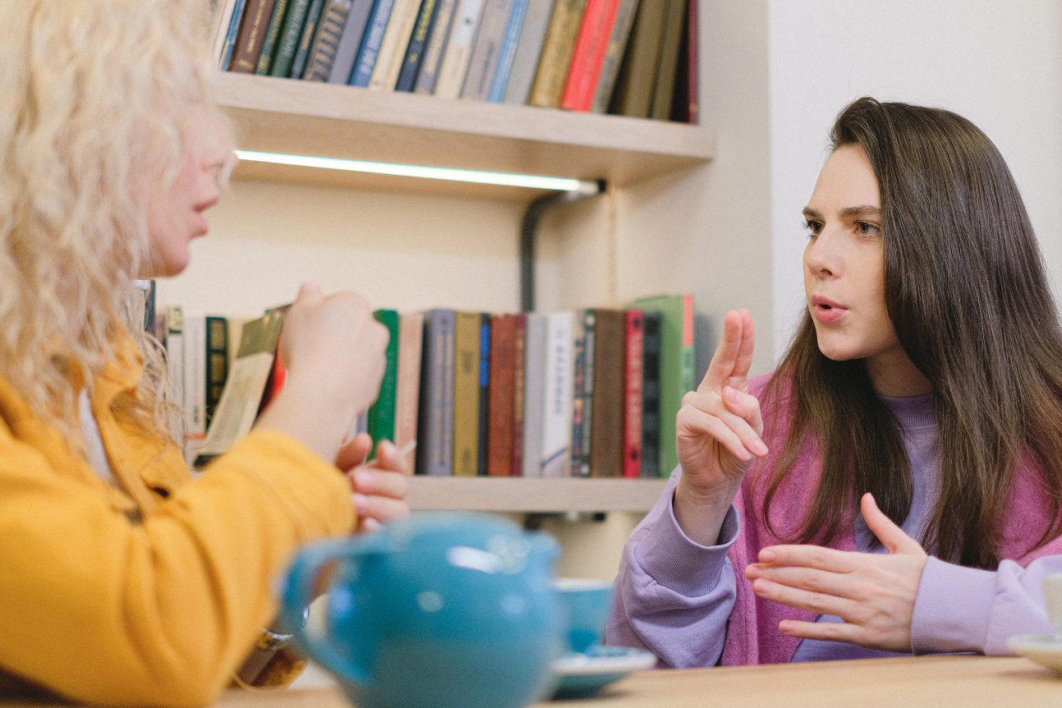
Our commitments

Commitment 1
We support and promote inclusion and participation for people with disability.

Commitment 2
Our leaders and staff demonstrate attitudes and practices which ensure people with disability are not discriminated against.

Commitment 3
Our services, programs and working spaces are accessible to people with disability and designed to keep everyone safe.

Commitment 4
We provide equal employment and leadership opportunities for people with disability.

The social and human rights models of disability
Our Plan is guided by strengths-based, person-centred approaches rooted in the Social Model and Human Rights Models of disability.
The Social Model focuses on removing barriers created by society – such as stigma, discrimination, and inaccessible environments – rather than viewing disability as a limitation within the individual. It asserts that people are disabled by the environment they live in, not by their bodies.
The Human Rights Model builds on this by affirming that disability can never be used as a reason to deny access, opportunity, or equality. This model:
- Recognises disability as a natural part of human diversity that must be respected and supported.
- Affirms that people with disability are experts in matters that affect them.
- Emphasises that equality does not mean treating everyone the same.
- Places responsibility on governments and organisations to take proactive action.

Using person first language
Throughout this Plan, we use person-first language, which places the individual before their disability. For example, “person with disability,” “victim survivor with disability,” or “staff with disability”. This approach aligns with guidance from People with Disability Australia, the national peak body for disability rights and advocacy.
We acknowledge that language preferences vary. Some people choose identity-first language, such as “I’m a disabled person,” “I’m a Deaf person,” or “I’m an autistic person.” This reflects pride in identity and connection to community or culture. Others may not identify as disabled at all.
We respect every individual’s right to define their identity and experiences. Our commitment is to listen, affirm, and use the language that each person prefers.
To support inclusive communication, we encourage staff to read People with Disability Australia’s Language Guide, available here: https://pwd.org.au/resources/language-guide/


Driving change through this Plan
In July 2024, we set up a Disability Working Group to create our first Disability Access and Inclusion Plan. This group includes staff with lived experience of disability and others from across FVREE who are committed to promoting inclusion.
To shape the Plan, the Working Group conducted a comprehensive audit using a tool created by Women with Disabilities Victoria and updated through the Victorian Government’s Family Violence Disability Practice Lead Initiative (2022 – 2025). This audit helped us identify barriers and the actions needed to make FVREE more accessible and inclusive.
We then partnered with Women with Disabilities Victoria to review the draft Plan and provide expert advice. Their feedback strengthened the Plan and ensured our commitments reflect best practice. We thank Women with Disabilities Victoria for their ongoing support, leadership and advocacy for the rights, safety, and inclusion of women and gender diverse people with disability.
The Disability Working Group will continue to meet regularly to drive this work forward. Progress will be reported to our Executive Leadership Team and Board, ensuring accountability at every level.
This Plan also aligns with disability inclusion initiatives underway in The Orange Door network in Melbourne’s Inner and Outer East.

Our focus areas
This plan focuses on four key areas to drive meaningful change. Each area includes clear actions, and we’ll track progress through a detailed implementation plan with timelines and deliverables.

Partnering with people with disability and disability organisations
Working together to ensure lived experience shapes everything we do.

Increasing employment and building workforce capability
Creating opportunities for people with disability and equipping our team with the skills to deliver inclusive services and programs.

Making our spaces and communications accessible
Ensuring our physical environments and information are welcoming and easy to navigate for everyone.

Improving service access and disability inclusive family violence practice

Embedding inclusion in all aspects of our work so that victim survivors and program participants with disability can access support without barriers.

Partnering with people with disability and disability organisations

Action 1
Act as an active ally by promoting attitudinal change, challenging ableism, and embedding the principles of the Social Model and Human Rights Model of disability in our work.

Action 2
Actively collaborate with specialist disability services, advocacy organisations, and external experts with lived experience of disability.

Action 3
Support meaningful participation and partnering with people who have lived experience of disability.

Increasing employment and building workforce capability

Action 4
Develop pathways and processes to actively recruit people with disability and work towards representation at all levels of employment.

Action 5
Provide an accessible recruitment and onboarding process to support people with disability in applying for roles.

Action 6
Strengthen policies and procedures for workplace adjustments and return-to-work transitions to specifically address the needs of staff with disability.

Action 7
Deliver organisation wide training to build foundational understanding of disability, ableism and unconscious bias, alongside targeted leadership training.

Action 8
Deliver comprehensive training on disability inclusive practice to staff who deliver programs and services.

Action 9
Develop organisational frameworks to guide best practice supervision for staff with disability and for staff supporting people with disability.

Making our spaces and communications accessible

Action 10
Make our spaces welcoming and physically accessible, including reception, client rooms, work areas and shared amenities.

Action 11
Update our Emergency Management Plan to clearly outline response procedures and evacuation protocols for people with disability.

Action 12
Train staff in accessible communication methods and embed these into practice.

Action 13
Ensure digital and print communications, including our website and client resources, are inclusive and available in accessible formats.

Action 14
Identify and promote accessibility features in commonly used computer programs and applications to support staff in their work.

Action 15
Deliver events and activities that are accessible and inclusive for people with disability.

Improving service access and disability inclusive family violence practice

Action 16
Equip staff with best practice guidance to deliver accessible and inclusive services and programs for people with disability.

Action 17
Establish continuous improvement processes to monitor and strengthen inclusive practice when working with people with disability.

Action 18
Establish a regular data reporting process to review service access and monitor inclusive practice for people with disability.


Phone: (03) 9259 4200
Email: getintouch@fvree.org.au
Postal: PO Box 698, Ringwood, VIC, 3134
Website: fvree.org.au

Women with Disabilities Victoria (2025) Facts on Violence Against Women with Disabilities. Other forms of discrimination include racism, ageism, classism, transphobia, homophobia.
Centre of Research Excellence in Disability and Health (2020) Violence against people with disability in Australia.
Robinson, S., valentine, k., Marshall, A., Burton, J., Moore, T., Brebner, C., O’Donnell, M., & Smyth, C. (2022). Connecting the dots: Final report (Research report, 17/2022). ANROWS.
Australian Institute of Health and Welfare (2025) People with disability www.aihw.gov.au/family-domestic-and-sexual-violence/population-groups/people-with-disability
These descriptions of the social and human rights models of disability have been informed by: People with Disability Australia (2021) PWDA Language Guide: A guide to language about disability.

